  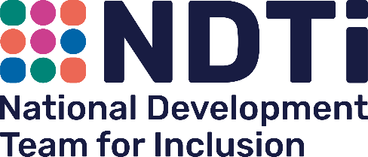 |  | 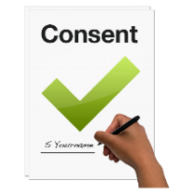 | 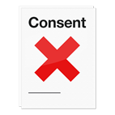
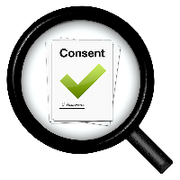   | 1. I have had an information sheet about this fact-finding project or the work has been explained to me.  I understand the information and would like to take part. | Yes ☐ | No ☐
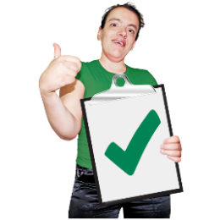 | 2. I have had information about how my personal data will be used and my rights relating to the information that is held about me. | Yes ☐ | No ☐
 | 3. I understand that I can stop taking part at any time and I can choose what happens to the things I have said. | Yes ☐ | No ☐
   | 4. I understand that if I stop taking part it won’t matter and will not affect anything else that I do. | Yes ☐ | No ☐
 | 5. I am happy for audio transcription and notes to be taken in the meeting.  I understand that I can ask for the things I say to be taken out of the notes if I change my mind about taking part in this piece of work. | Yes ☐ | No ☐
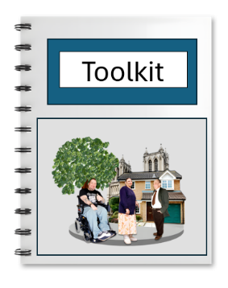 | 6. I understand that NDTi will make a toolkit which may include things I say, but that my name will not be used. | Yes ☐ | No ☐
 | 7. I understand that if the person I talk to thinks I or someone else is at risk of harm they will have to tell someone else what I have said. | Yes ☐ | No ☐

 | My name is  ------------------------------------------------
 | Date:  ------------------------------------------------
 | The NDTi team member’s names are  ------------------------------------------------  ------------------------------------------------
Thank you for filling in this form

