Equipment
- Exercise books
- Printed images (optional)
- Tablets or laptops (optional)
- Sticky notes (optional)

Slide 2 – Ground rules
Revisit the class rules to ensure a respectful environment. This lesson introduces practical information about voting, so it’s important that learners feel comfortable asking questions.
Suggested rules:
- We take turns – everyone can share their opinion.
- We treat all opinions as important.
- We listen and use respectful words if we disagree.

Slide 3 – Three ways to vote
Learners look at three images (speech bubbles, envelope, ballot box) and guess the three ways to vote:
- In person
- By post
- By proxy
This is a simple warm‑up to activate prior knowledge.

Optional alternative tasks
- Picture sorting: Provide three images and three labels; learners match them.
- Movement task: Place the three images around the room; learners walk to the one they think represents each voting method.
- Mini whiteboards: Learners draw what they think each picture means.

Slide 4 – Video: three ways of voting
Play the short YoutTube video explaining the three voting methods.

Optional alternative tasks
- Pause‑and‑check: Pause after each method and ask learners to summarise it in one sentence.
- Visual recap: Provide three screenshots from the video and ask learners to label them.

Slide 5 – Voting in person
Explain that to vote in person, you visit a polling station. These are usually in community buildings such as schools, churches, or halls. Staff can help, and learners may bring a trusted adult over 18.
Images include:
- Polling station sign
- Community building
- Two friends

Optional alternative tasks
- Local map activity: Show a map of the area and identify nearby community buildings.
- Vote role‑play: Set up a “polling station” table and walk learners through the process.
- Picture matching: Match images of buildings to the label “polling station”.

Slide 6 – Poll cards and photo ID
Explain that a few weeks before an election, a poll card is sent by post. It tells you where to vote. Learners can also check their polling station online. Remind them they must bring Photo ID.
Images include:
- Poll card
- Passport
- Driving licence
- Other accepted ID

Optional alternative tasks
- ID sorting: Provide images of different cards; learners sort into “accepted” and “not accepted”.
- Checklist creation: Learners create a simple “What to bring on voting day” checklist.
- Draw‑your‑ID: Learners draw a simple version of an ID card (name + picture only).

Slide 7 – Think, Pair, Share: postal voting
Learners consider:
- Why might someone prefer to vote by post?
- Who can help us apply for a postal vote?
Show the gov.uk link for applying online and an image of a postbox.

Optional alternative tasks
- Scenario cards: Provide short scenarios (e.g., “I work long hours”, “I find travel difficult”) and ask learners which ones might choose postal voting.
- Pros/cons table: Learners complete a simple table with reasons someone might choose postal voting.
- Partner discussion: Learners discuss who they would ask for help (family, support worker, teacher).

Slide 8 – Applying for a postal vote
Show the website link and images of a postal vote form and postbox.

Optional alternative tasks
- Practice form: Provide a simplified postal vote form for learners to fill in.
- Step‑by‑step cards: Learners sequence cards showing the steps (apply → receive pack → complete → post).
- Group explanation: Learners explain the process in their own words to a partner.

Slide 9 – Video on proxy voting
Play the video explaining proxy voting.

Optional alternative tasks
- Pause‑and‑summarise: Pause after each section and ask learners to summarise.
- Visual storyboard: Learners sequence 4–6 images showing the proxy voting process.

Slide 10 – What is proxy voting?
Learners work together to write a definition of proxy voting. Show an image of a person holding a proxy card.
Explain that proxy voting means someone votes on your behalf.

Optional alternative tasks
- Fill‑in‑the‑blank definition: “Proxy voting means someone you ___ votes for you.”
- Role‑play: One learner acts as the voter, another as the proxy, and they walk through the steps.
- Matching task: Match “proxy voting” to the correct definition card.

Slide 11 – Reasons you can vote by proxy
Learners reveal the four reasons using a hangman style activity. Reasons:
- Overseas voter
- Away
- Disability
- Work / Military service

Optional alternative tasks
- Reveal cards: Instead of hangman, reveal each reason under a flap or card.
- Sorting activity: Provide several reasons and ask learners to sort into “allowed” and “not allowed”.
- Scenario matching: Match example situations to the correct reason.

Slide 12 – Quiz
Questions include:
- What are the three ways you can vote?
In person, by post, by proxy
- What is the name of the place where you vote in person?
Polling Station
- What do you need to take with you?
Photo ID (or voter authority certificate)
- Will you have to travel far?
No, the Polling station should be close to where you live
- Can you get help to vote?
Yes, someone can come with you to vote or you can ask polling station staff for help
- Do you need to explain why you want a postal vote?
No
- How do you apply for a postal vote?
Complete and online form
- What is it called when someone votes for you?
Voting by proxy
- Where can you find out more?
The Electoral Commission website

Optional alternative tasks
- Picture‑based quiz: Learners match images to answers.
- Movement quiz: Learners move to labelled areas of the room (e.g., “postal”, “proxy”, “in person”).
- Team quiz: Learners answer in small groups using mini‑whiteboards.

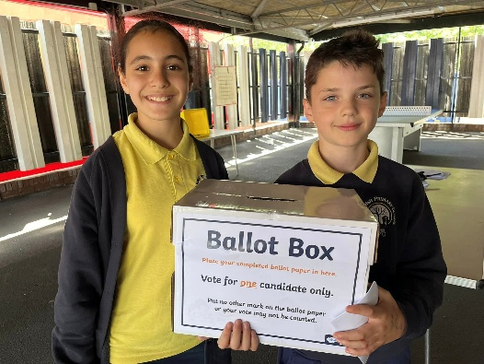
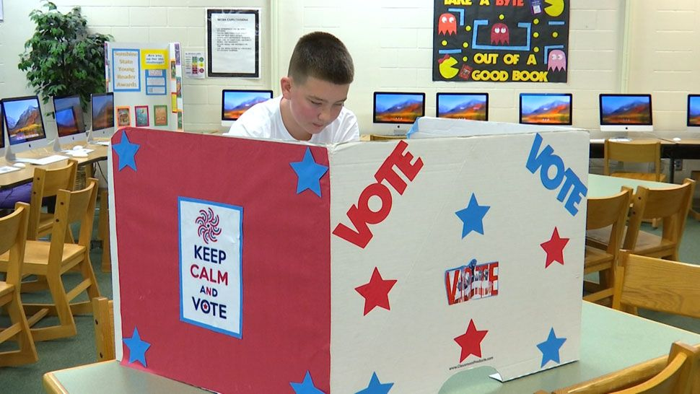

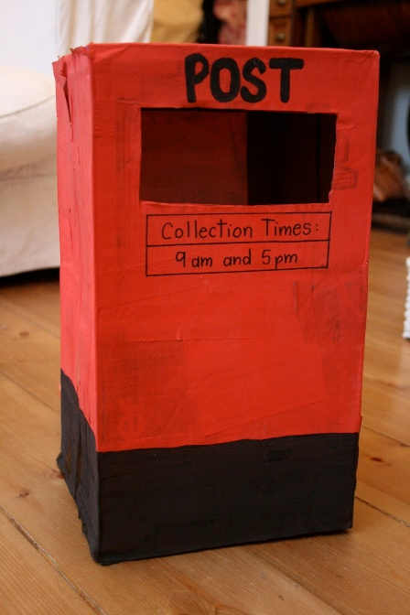

Slide 14 – Different ways to vote Easy Read
Learners can work through the Easy Read document together.

Optional alternative tasks
- Read‑together: Teacher reads aloud while learners follow.
- Highlighting task: Learners highlight key words or ideas.
- Matching definitions: Provide a simplified glossary to match to the Easy Read.

