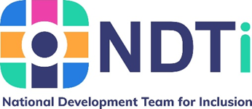
What matters to people with learning disabilities and their families in Bury.

 | Hello, we are Lyn and Madeline from the National Development Team for Inclusion (NDTi).
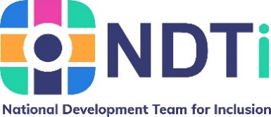 | NDTi is a ‘not for profit’ organisation that aims to make things better for people who need support. If you are looking at this on your computer you can find out more about us by clicking here
Bury Council want to make sure people with learning disabilities have access to opportunities that will help them, grow and live their best lives with positive links to their community.

To do this, they have asked NDTi to talk to people with learning disabilities and the important people in their life about how they would like to spend their days.
They have asked us to help them by talking to people to find out:

- what is important to have a good life
- what people like to do, and
- what people want to do
 | What you tell us about what you think will be shared with Bury Council.
 | We won’t share your name or any information about you, only what you have said.
 | You can tell us what you think in 3 different ways.
- Fill in a postcard.

You can do this on your computer, or you can:
- print the postcard,
- fill it in,
- take a photo and
- email the photo to us at: equallivesteam@ndti.org.uk
A copy of your postcard will be stored on NDTi computers that are secure.
The folders with your postcard in will be password protected.
Only the team doing this work will be able to see your postcard on these computers.
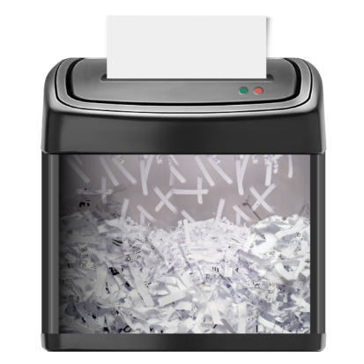 | Your email and email address will be deleted and not stored anywhere.
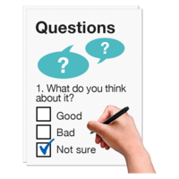  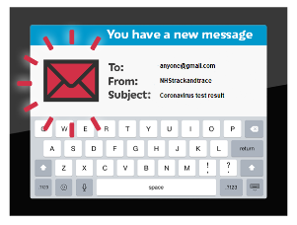 | - Fill in a questionnaire.  You can do this online at: www.onecommunitybury.co.uk/learning-disability-day-services-in-bury  Or you can:  - print the survey  - fill it in,  - take a photo, and  - email the photo to us at:  equallivesteam@ndti.org.uk
 | The online survey is anonymous, this means we won’t know who you are.
A copy or photo of your printed survey will be stored on NDTi computers that are secure.
The folders with your printed survey in will be password protected.
Only the team doing this work will be able to see your printed survey on these computers.
 | Your name, email message and email address will be deleted and not stored anywhere.
- Talk about what matters
in a self-advocacy group, in a community or day centre or with your friends and family.

You can then tell us what matters
in an email, in words or by drawing us a picture or sending us a short video.

The email, drawing or short video you send us will be stored on NDTi computers that are secure.
The folders with your email, drawing or short video in will be password protected.
Only the team doing this work will be able to see your email, drawing or short video on these computers.
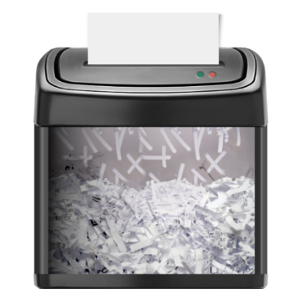 | Your name and email address will be removed from the message when saved on NDTi computers.  From your video we will write down what you say. We will not share the video with anyone else.
 | Once you have sent in the copy of the survey, postcard, video or drawing you WILL NOT be able to ask for it to be deleted.
 | This is because we won’t know who you are, as we will have deleted your email.
We will come to Bury in the New Year and have some fun events where you can tell us more in person.
Keep a look out for more information about the events in the New Year.
 | NDTi will keep a copy of what you say until December 2023.
 | NDTi will destroy their copy of your postcard, drawing, email message or video after this date.
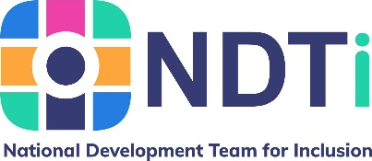 | If you have any questions or want to find out more you can contact us by sending an email to: equallivesteam@ndti.org.uk

