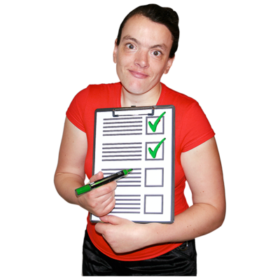

Top Tips to help with
Digital Inclusion

What was the goal?
To coproduce some top tips of how health and social care services, partners and others should work to ensure that people with learning disabilities and autistic people can be digitally included. Or reduce digital exclusion which has negative health inequalities impacts.

Process
- Scoping of range of documents (over 20 sources documents, research, web info)
- Approaching people who were working on digital inclusion in this arena from across academia, self-advocacy, and system and voluntary sector (see scoping document list)
- Develop simple question framework for engagement
- Ran workshops online
- Themed and summarized all info into top tips

Who was involved from different alliances and wider voluntary sector
- Good Things Foundation
- The Race Equality Foundation and Mental Health Consortium
- Westminster society
- The Open university, Manchester Metropolitan University, Lancaster University
- The RICS centre
Self - Advocates from:
- My Life My Choice
- Talkback -UK
- Inclusion North
- Inclusion East
- Pathways
More people joined by sharing on social media

Who was involved with lived experience?
- Questions framework co-produced with people with lived experience
- Workshops were co-facilitated
- 2 workshops including 18 people with lived experience
- Some people joined from another digital inclusion group- we facilitated an extra session with a further 15
- Phone calls with another 3 people

Outputs
- Summary of written evidence
- Top tips for those using digital approaches to health- also useable by people with learning disabilities and other voluntary sector
- Designed graphically for simple and wide dissemination

Impacts of the work
• Better understanding of the impacts of increasingly digitalized health and care provision on people with learning disabilities/ autism and other excluded groups
• Learned about and shared and discussed great work that has already been done
• People were able to share their experiences and let the health, social care and voluntary sector know how best to support them
• Resource available for all system – health and care and beyond- about how to ensure people can be digitally included.
• Includes what to do in designing digital systems, providing support to people, and practical terms around resources and equipment that people need.
Connections between Health and wellbeing alliance work with academics and researchers
• By using the resource, we can reduce the impacts of potential digital exclusion in health inequalities for people with a range of different support and communication needs.

Scoping

- Draft (unpublished) paper - Online social connections and internet use among people with intellectual disabilities in the UK during the Covid-19 pandemic (Source Sue Caton)

- Supporting people with learning disabilities to use technology (Source Jane Seale):

- Jane Seale (2020) Keeping connected and staying well: the role of technology in supporting people with learning disabilities during the coronavirus pandemic, Milton Keynes, The Open University.

- Information and communication technology use in daily life among young adults with mild-to-moderate intellectual disability

- Cognitive Accessibility for Digital Health: a preliminary study

- Lewisham Speaking up -research on digital inclusion since the covid 19 pandemic

- Research summary -learning disability - ofcom report - Disabled users access to and use of communication devices and services

initiatives, websites and related research

- One Digital website: One Digital was a UK-wide digital inclusion programme developed by a collaborative partnership between Age UK, Citizens Online, Clarion Futures (part of Clarion Housing Group), Digital Unite and Scottish Council of Voluntary Organisations (SCVO).

- Inclusion hub website: a crowd-sourced database helping businesses understand and improve digital inclusion.

- Digital Lifeline an emergency response project getting devices, data and digital skills support to digitally excluded people with learning disabilities in England. It was funded by the Department for Digital, Culture, Media & Sport (DCMS) and delivered by Good Things Foundation

- Towards digital inclusion – engaging older people in the ‘digital world’

- Beyond the digital Divide. Rethinking digital inclusion for the 21st century

- The use of internet based communication by people with autism

Articles/leaflets/blogs

- How tech can help social isolation

- Mental health technologies for people with learning disabilities

- Improving Digital Inclusion & Accessibility for Those With Learning Disabilities

- Doing digital inclusion with the most excluded: people with learning disabilities

- Digital inclusion. Using digital technology positively and safely

Impact of Covid

- The Impact of Coronavirus on People with Learning Disabilities and their Parents, Carers and Supporters: Survey findings (Source: Scottish Commission for Learning
Disability)

- How Coronavirus has affected people with learning disabilities and autistic people: easy read (Source: Social Care Sector COVID-19 Support Taskforce: People with Learning Disabilities and Autistic People Advisory Group)

- The Effect of the Coronavirus Pandemic on People with Learning Disabilities Across Wales: Phase One (Source: All Wales People First).
Impacts of the work
- Better understanding of the impacts of increasingly digitalized health and care provision on people with learning disabilities/ autism and other excluded groups
- Learned about and shared and discussed great work that has already been done
- People were able to share their experiences and let the health, social care and vol sector know how best to support them
- Resource available for all system – health and care and beyond- about how to ensure people can be digitally included.
- Includes what to do in designing digital systems, providing support to people, and practical terms around resources and equipment that people need.
- Connections between HWA work with academics and researchers

By using the resource, we can reduce the impacts of potential digital exclusion in health inequalities for people with a range of different support and communication needs.

