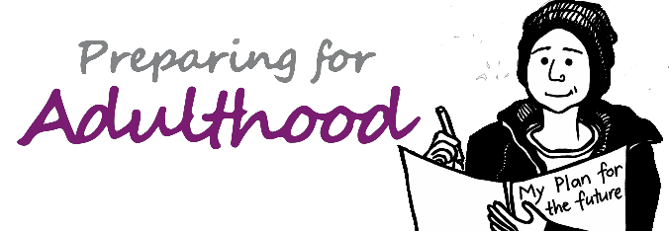

Key topics to cover at annual reviews from year 9
2019

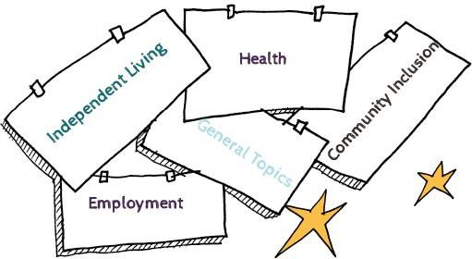

Contents:
Introduction
Preparation for the review meeting
Preparing for Adulthood areas to cover at the meeting:
Employment Independent Living Community Inclusion Health
General topics Apprenticeships
Useful Sources of Information

Key topics to cover at annual reviews from year 9...
Introduction
This checklist has been designed around the four life domains that are widely used to think about planning for an adult life in the community. Please see the Preparing for Adulthood website for more information: https://www.preparingforadulthood.org.uk/about-us/our-work.htm It is a simple aide memoire to ensure that all young people and their
families are being given the information they need, are being signposted to relevant sources of support and are being enabled to plan for a positive
future. The list is not exhaustive but does aim to take a holistic view of the young person and cover all major aspects of life. If you wish to add to it by making reference to specific local processes, documents or organisations, this will be possible if you download the Word version. Throughout the document, the assumption has been made that those responsible for convening reviews know their legal duties and these have not been spelt out in full. In order for the review meeting to run smoothly and with
real purpose, this checklist is best read by the review coordinator before the meeting but much of it can be completed during the meeting. The questions below highlight the need for preparation but it does not contain the person centred questions that should be covered with young people prior to the review meeting. An example of these is listed in the resources section.

For all young people, whether they have an education, health and care plan or not, the starting point has to be their wishes and feelings. From age 16, the Mental Capacity Act 2005 applies, and the young person’s voice should be heard, providing they have capacity to make the specific decision under consideration. It will be important to tell parents about this law well ahead of the young person’s 16th birthday and some useful resources on it have been included at the end.

The review should reflect any changes in their views; plans will need to capture aspirations and holistic outcomes that are in line with each other as well as what support needs to be put in place to make the outcomes possible. Finally, a good annual review will generate a clear set of actions to be followed up. These should identify who will do what, by when.

1

Preparation
2

Preparation | Yes/No/Partially
Has the young person been helped to understand what will happen at the meeting before the review?
What support has been put in place to ensure the young person’s views are captured and that s/ he can be present at the meeting? An example of this might be the use of photos or video
Has everyone who is relevant including the young person and anyone they want there, been invited?
Has all relevant paperwork been distributed 2 weeks ahead of the meeting in a form that everyone can understand?

Preparing for Adulthood areas to cover at the meeting
3
Employment

Employment | Yes/No/Partially
Has the young person received any careers information, advice and guidance in the last year?
Does the young person have an up to date vocational profile or CV?
Is there a summary of the vocational profile or of what’s important for this young person in work attached to the education, health and care plan?
In the last year, have work tasters and /or work placements been offered in line with the interests and skills identified in the vocational profile? What was the outcome of these?
Is the curriculum supporting the development of skills that the young person will need in the workplace?

Independent Living
4

Independent Living | Yes/No/Partially
Has the young person been asked about where they want to live in future and with whom?
Do the parent carers have a view on what should ideally happen and by what age? E.g. what are the parents’ or foster carers’ expectations for the young person post 18?
Has the family been given information on how to get onto the housing register?
Have the family and young person been signposted to support around housing?
Is the young person learning skills at school and at home that will help with living inde- pendently at home?
Does the plan reflect wishes around housing?

Community Inclusion

5
Community Inclusion | Yes/No/Partially
Does the young person have a circle of friends inside and outside of school/college?
Is it clear what is being done to support the young person’s friendships inside and outside of school/college?
Have options for more community activities been explored and followed up?
Are there any ways that the young person can contribute to their community and become better known? E.g. volunteering opportunities

Health

6
Health | Yes/No/Partially
Is the young person registered with a local GP?
If appropriate, is s/he on the all age learning disability register at the GP surgery?
Are the family aware of the benefits of an annual health check from age 14?
Is it clear what reasonable adjustments are likely to be needed to support the child’s mental or physical health? E.g. first or last appointments, easy read information provided, etc.
If the young person will need adult health services, who will plan for the health transition with him/ her?
Has the young person had a thorough eye check?
Is s/he registered and attending appointments with a dentist?
Is the young person likely to be eligible for continuing health care and continuing care arrangements? If so, are the family aware of local arrangements for assessing eligibility?
Does the curriculum support young people to have a healthy lifestyle?
Are the young person’s emotional and mental health needs being met? If so, by whom?

General

7
General | Yes/No/Partially
Are the family/young person familiar with the local offer?
Do the family/young person need additional support with accessing the local offer?
Have the parent carers been given easy to understand information about the Mental Capacity Act 2005?
Have parents been reminded about the need to assume that their son or daughter has capacity unless proven otherwise?
Have the outcomes been updated in line with priorities identified?
Are the outcomes SMART?
Are there clear actions and deadlines?

Useful sources of information

Mental Capacity Act 2005

Helpful video for parent carers: https://www.youtube.com/watch?v=tsthYJV0yig

Mental Capacity Act 2005 Factsheet: https://www.preparingforadulthood.org.uk/downloads/young-people- and-family-participation/factsheet-the-mental-capacity-act-2005-and- supported-decision-making.htm

MCA guide for parent carers:
https://www.hft.org.uk/wp-content/uploads/2017/08/Using-the-MCA.pdf

Employment
Routes into Work Guide: https://www.preparingforadulthood.org.uk/downloads/employment/ routes-into-work-guide.htm

Housing
Guide to different housing options: https://www.preparingforadulthood.org.uk/downloads/independent-living/ no-place-like-home-guide.htm
Community Inclusion
8

The Inclusion Web: https://www.ndti.org.uk/news/launching-the-new- inclusion-web

Good health
Annual health checks:
https://www.nhs.uk/conditions/learning-disabilities/annual-health-checks/

Guidance on reasonable adjustments: https://www.gov.uk/government/collections/reasonable-adjustments-for- people-with-a-learning-disability

Acknowledgements
We would like to thank staff at Plymouth City Council and Gloucestershire County Council for their help in producing this document

May 2019

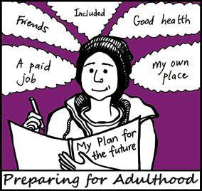

01225 789135
preparingforadulthood.org.uk

