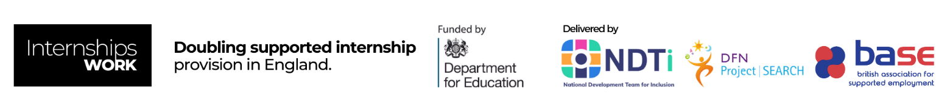
Action Plan
To be used by Local Authorities as part of the Internships Work programme

Local Authority Name
Name of Person Responsible for Action Plan
Email Address
Telephone Number

Please note this action plan is a live document that will be developed over the life of the programme. Support will be available from your NDTi Regional Lead to support you with this plan.

About Internships Work
Internships Work is a programme funded by the Department for Education, which will double the current supported internship provision in England by enabling 4500 young adults, aged 16-24 with additional needs, to benefit from a supported internship per year by 2025. It is designed to support more young people with additional needs to have greater choice and control over their future, opening up opportunities that prepare them for adult life and independent living

Topic | Outcomes | Actions | Year  1 | Year  2 | Year  3 | Lead
Data | Data is available re:  - Young people following Supported Internships and outcomes from supported Internships over the last five years  - Average age of young people taking part in supported internships  - Young people with EHC plans taking part in traineeships and apprenticeships  - Young people moving into paid employment from other study programmes  - Prediction of number of young people who could benefit from Supported Internships over the next four years
Partnership Readiness | - There are strong working relationships between parents, young people, education, health and social care (children and adult) services, employment services, schools, colleges and training providers  - All partners are engaged in the employment forum and are signed up to a shared vision of increasing the number of Supported Internships
Information | The Local Offer website and printed materials explain:  - What Supported Internships are  - How young people access them  - Where and how they are being offered  - What support an internship offers  - What the expected outcome of a supported internship is  - Contact details  Young people receive high quality information, advice, and guidance about careers and employment pathways, in line with the Gatsby benchmarks  Events are held during the year which bring together local services, providers, employers, young people and families to raise aspirations for paid work for young people with SEND
Outcomes In EHCPs | Professionals writing or contributing to Education, Health and Care plans are confident in co-producing outcomes that are based on young people’s aspirations and the evidence of what works to achieve employment
Annual Reviews from Year 9 | - At the year 9 review, intentional planning for employment (and the other PfA outcomes) begins (vocational profiling, work experience etc.) in line with the Gatsby benchmarks  - At the year 11 annual review, the Education, Health, and Care plan is amended to reflect the study programme the young person will be following and the support that will be in place to support employment outcomes
Trained Job Coaches | There are enough trained job coaches in the local area to support all young people with EHC plans into employment | For example:  Occupational Standards Training provided by BASE will be delivered in the local area
Vocational Profiling | Person-centred, comprehensive vocational profiling is carried out during key stage four
Curriculum | - All post 16 providers in the local area are delivering high quality, work related, study programmes for all young people with Education, Health and Care plans so that duplication is avoided, and progression embedded  - These study programmes include Supported Internships, Traineeships, Supported Apprenticeships, and personalised study programmes leading to paid employment or self-employment
Employer Engagement | There is a local employer engagement strategy in place, and good relationships with local large employers as well as SMEs providing a wide range of opportunities for young people including work visits, tasters, placements, and paid work.  The strategy links to other employer engagement strategies, for example, the LA recovery plan. | For example:  Training for the employment forum on employer engagement provided by DFN Project Search will be delivered in the local area
Work Experience | All young people with Education, Health and Care plans have work experience in line with the Gatsby benchmarks
Supported Internships | The number of young people accessing supported Internships increases year on year. Our target for 22/23 is xxx, 23/24 xxx and 24/25 xxx
Social Value | The Local Authority has a Supported Internship programme within the Council.  The Local Authority’s recruitment processes are accessible for people with additional needs.  The Local Authority is a disability confident employer and seeks support to continue to improve.  There are several ways in which the Local Authority ensures that families understand the positive impact of work for young people with SEND and also how to navigate the benefit system.  For example:  - Co-production with the parent carer forum and other parent groups  - The Local Offer  - The SENDIAS service can provide families and young people with information about employment and benefits  - SEND Case Officers and all professionals have training around  employment pathways and the benefits system

