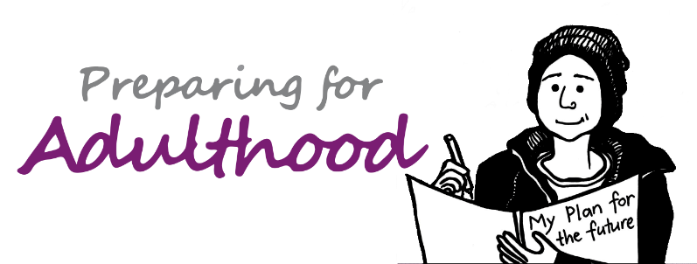

Final Annual Review Guide

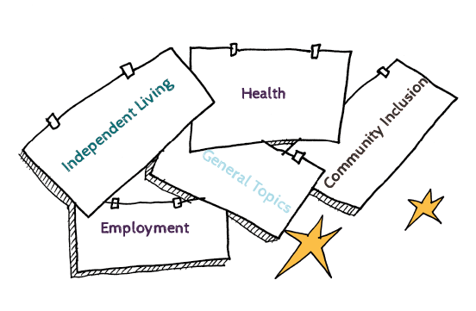

Introduction

This document is designed to help everyone involved in annual reviews to think about what a good final review would look like. It has been developed in response to wide recognition that more attention and time needs to be given to marking the occasion when a young person is ready to come out of tertiary education and move into adulthood. It is an important opportunity to celebrate achievements and milestones at whatever age the final review happens.

For the review meeting to go well, the young person needs to be in a good place and that means good preparation from an early age. So the final review meeting involves less about going through the Education, Health and Care plan
and more about taking stock of the young person’s achievements, their hopes and ambitions and checking what actions need to be taken to allow the young person to have a good life in the community. While there is little point in going through the whole plan in the meeting, it is nonetheless worth looking at the aspirations and outcomes sections. The meeting itself should celebrate what has been achieved by the young person and acknowledge the support of parent carers and any others who have played an important role in their journey. It is a good idea to record these and a section has been added below for that purpose.

The document offers a brief section on when a plan should cease and is then structured under the four Preparing for Adulthood pathway headings of: employment, independent living, community inclusion, and health, plus a section for more general discussion. It offers suggested prompts to those involved in the review process but is not an exhaustive list. There is already in existence a Preparing for Adulthood document about themes to consider at annual reviews from year 9 onwards which can be found here .This document covers similar topics but with a view to ensuring that when Education, Health and Care plans are expected to cease, appropriate actions are taken in a timely way to achieve a lifestyle that reflects the young person’s hopes and dreams and upholds their rights, no matter what level of support they require. To this end, a suggested format for action planning is included.
When should a plan cease?

Section 45 of the Children and Families Act specifies the circumstances for ceasing an EHC plan.

The special educational needs Code of Practice says that LAs must not cease to maintain the EHC plan simply because the young person is aged 19 or over but there are some clear times when a plan should end:

- A young person aged 16 or over leaves education to take up paid employment (including employment with training but excluding apprenticeships)
- The young person enters higher education
- A young person aged 18 or over leaves education and no longer wishes to engage in further learning
- The young person turns 25

Things that we want to celebrate!

Employment

Employment | Comments
Does the young person want to work?

Is there a current vocational profile and where is it kept?

What can be done to develop these prospects further?

What support is in place to make sure that paid work is possible?
What is the local arrangement for follow on support once paid work is achieved?

Who needs to be involved in keeping the plans on track?
Any issues need an urgent referral /action?

Independent Living

Independent Living | Comments
Has the young person expressed their wishes and views about their future accommodation?

Is the current housing situation likely to be long term? This should be determined by both the young person and the family but in line with the Mental Capacity Act 2005.
How important is location of accommodation in relation to work/work opportunities?

Have appropriate steps been taken to apply for housing if it is needed?

Are there any urgent issues relating to either self - care or daily living that should be addressed?

Does everyone know where to get information, advice and guidance around housing and support?

Community Inclusion

Community Inclusion | Comments
How does the young person feel about being more independent? And moving out of education?

What plans does s/he have around maintaining friendships with school/college peer group? What can be done to support this?
Does the young person have any connections with long term social or sporting groups/clubs? What can be done to sustain these?
How does the young person get around? Has travel training taken place?

Is adult social care involved in supporting the activities that the young person does during the week? If so, is this working well?
Are any referrals needed and if so, who is doing this?

Good Health

Good Health | Comments
Does the young person understand about good health and how to maintain this?

Are the young person and the family aware of the benefits of work on both physical and mental health?

Is the young person registered with the GP, a dentist, and an optician?

Does the young person have ongoing health issues?

Does s/he regularly see health professionals about these? If so, which professionals and how often?
Has a health transition plan been implemented so that the young person is able to access adult health care as needed?
Is there a Ready Steady Go¹ programme for transition into health services in the area?

Good Health continued…
If the young person is eligible for an annual health check2, are these happening?

Does the young people have a health action plan3?
Is anything needed to help the young person eat a healthy diet?

Is anything needed to help the young person be active?

Is anything needed to help the young person have good emotional wellbeing and mental health?

Where can the young person and family get support need for any of the above?

‘Ready Steady Go’ and it’s follow on programme ‘Hello to adult services’ provide a tool for Health and social care service managers in children's and adults' services to work together in an integrated way to ensure a smooth and gradual transition for young. The programme also provides a structure to ensure that the patients and carers are appropriately supported before and partially after transfer to adult services as recommended in the NICE guidance. See:
2 Annual Health Checks
3 Health Action Plan

General

General | Comments
Are the family/young person familiar with how to get information about support services under the Care Act?

Are family carers aware that they can access support in their own right?

Has everyone received information about the Mental Capacity Act 2005 in formats they can access?

Actions and Deadlines

What needs to happen? | Who is doing this? | By when?
Employment

Independent living

Continued on the next page...

What needs to happen? |  | Who is doing this? | By when?
Community Inclusion

Good Health

General

