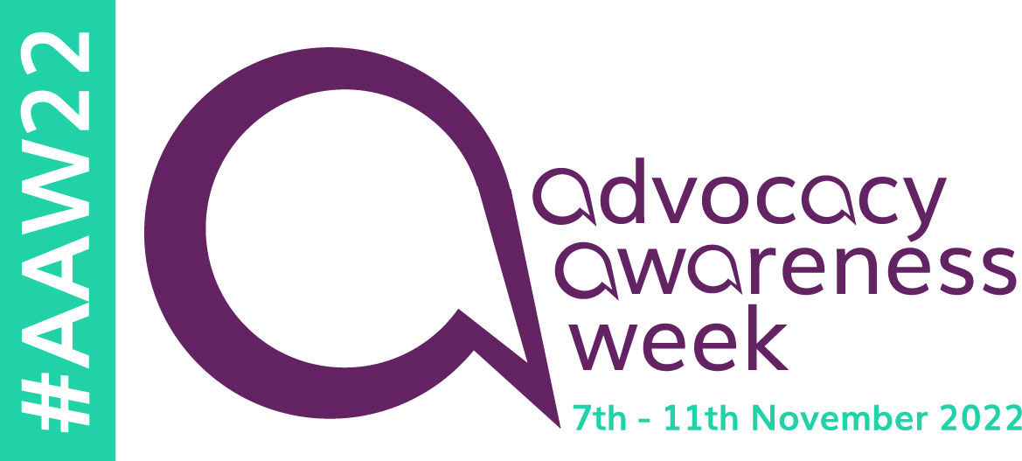
AAW22 template news release
The template below is a guide for you to use as you wish. You might want to use the whole thing and just add your own case studies and quotes, or you could write your own version using some of the paragraphs to describe the key messages.
------------------------------------------------------------------------------------------------------------------------------------

Upholding your Human Rights through advocacy

This week is Advocacy Awareness Week 2022 (#AAW22) and to demonstrate how advocacy supports your rights, each day will shine a light on an element of the Human Rights Act. The week-long campaign, which is now in its fifth year, is coordinated by the National Development Team for Inclusion (NDTi) and this year is supported by The British Institute of Human Rights and advocacy providers across the UK. <<insert your organisation’s name>> is proud to be supporting the week.
Human rights are basic rights everyone can expect and public authorities have a legal duty to respect and protect them. Protecting Human Rights should run through the care and support services you receive and make sure you’re involved in decisions about your care.
But what happens if you find it harder to express your views and communicate your wishes or if you’re in a complex situation? In certain circumstances you can access the support of an independent advocate. Advocates have a key role in supporting people to understand their human rights, ensuring these are respected and upheld by public bodies and raising concerns and challenges when they are under threat or at risk. Advocates are there to listen to what’s important to you, support you to understand your rights and help you to communicate your views and wishes to health and care providers and others.
Insert case study here:
Insert quote from advocacy organisation here:
Gail Petty, NDTi’s Advocacy Lead, said:
“We want to make sure people know about independent advocacy and how it can help them achieve their rights. We also want to remind commissioners why good quality independent advocacy is essential to people in our communities.
This week is an opportunity to celebrate great advocacy and share stories about the power and impact advocacy can have in upholding people’s rights.”
Carlyn Miller, Head of Policy at the British Institute of Human Rights, said:
"Human rights are all about putting power into the hands of ordinary people – and advocates play a key role in making that happen. Advocates can empower people to understand their human rights when accessing public services and also make sure the people providing those services are aware of their legal responsibilities.
“Using the language of human rights law reinforces that human rights are just that – rights enshrined in law and not favours or special treatment. Advocacy Awareness Week is a great opportunity to highlight the power of having those conversations outside the courtroom, to stop issues escalating and protect people before their rights are breached as well as ensuring justice when breaches have already occurred."
Daily themes
- Monday: Right to life. Examples can include neglect or abuse in care settings that puts your life at risk or professionals withdrawing or refusing treatment because you have a disability.

- Tuesday: Right to be safe from inhuman or degrading treatment. This can include serious harm from a lack of care or support, severe abuse or ill-treatment by others. Public services staff must protect you from serious harm.

- Wednesday: Right to liberty. This looks at restriction of movement. Restrictions must be lawful, for a good reason and the least restrictive option.

- Thursday: Right to respect for private and family life. Some examples are being involved in decisions about your life, care and treatment, staying in contact with loved ones and maintaining wellbeing.

- Friday: Right to be free from discrimination. This can protect you from being treated worse that other people, for example because of your race or having a disability. This right has to link to your other Human Rights.

Join the conversation on social media using the following hashtags: #AAW22 #HearMyVoice #HumanRightsAdvocacy #AdvocacyinAction
How to find support
Your local council has a duty to commission certain types of independent advocacy, for example Care Act Advocacy, Independent Mental Capacity Advocacy, Independent Mental Health Advocacy and advocacy to help you with making complaints about NHS care and treatment. Advocacy will be provided by an organisation, that is separate from the council, NHS and other care and support services. Advocacy should be free, independent, and confidential. Your local council should be able to let you know who the advocacy providers are in your area.
ENDS

Notes for editors
On 22 June 2022, the Justice Secretary presented a Bill in Parliament that would repeal our Human Rights Act. This is called the Bill of Rights.
The National Development Team for Inclusion is a social change organisation working to enable people at risk of exclusion, due to age or disability, live the life they choose. Through change and development work, research and evaluation and best practice examples, NDTi inspires and supports policymakers, services and communities to make change happen - change that leads to better lives. Through its programme of work NDTi manages the Advocacy Charter and Advocacy Quality Performance Mark https://qualityadvocacy.org.uk/

